Inheritance

Bapak.java

public class Bapak {

int tangan;

int kaki;

public Bapak(){

this.tangan=2;

this.kaki=2;

}

public void berdiri(){

System.out.println("Berdiri");

}

public void berjalan(){

System.out.println("Berjalan");

}

}

Anak.java

public class Anak extends Bapak {

public void bernyanyi(){

System.out.println("lalaa..alaa...");

}

}

BapakAnak.java

public class BapakAnak {

public static void main(String[] args) {

Bapak bapak1 = new Bapak();

Anak anak1 = new Anak();

System.out.println("Jumlah Tangan = " + bapak1.tangan);

bapak1.berjalan();;

System.out.println("Jumlah kaki = " + anak1.kaki);

anak1.berdiri();

}

}

Out put

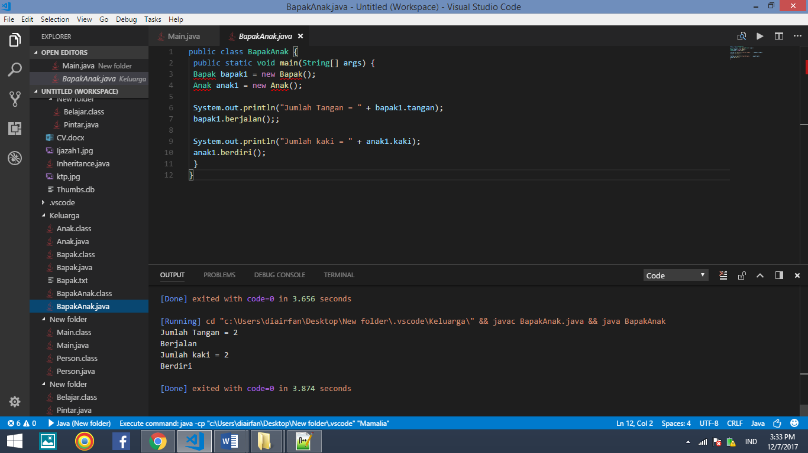

Polimorpishm

// Nama file : Polimorphism.java

// Contoh penerapan konsep polimorphism

public class Polimorphism {

public static void main(String[ ] args) {

cetakObyek(new Balok());

cetakObyek(new PersegiPanjang());

cetakObyek(new BangunDatar());

cetakObyek(new Object());

}

public static void cetakObyek(Object obyek) {

System.out.println(obyek);

}

} // Akhir kelas Polimorphism

class Balok extends PersegiPanjang {

public String toString() {

return "Mempunyai sisi panjang, lebar dan tinggi";

}

}

class PersegiPanjang extends BangunDatar {

public String toString() {

return "Mempunyai sisi panjang dan lebar";

}

}

class BangunDatar extends Object {

public String toString() {

return "Mempunyai berbagai bentuk";

}

}

Out put

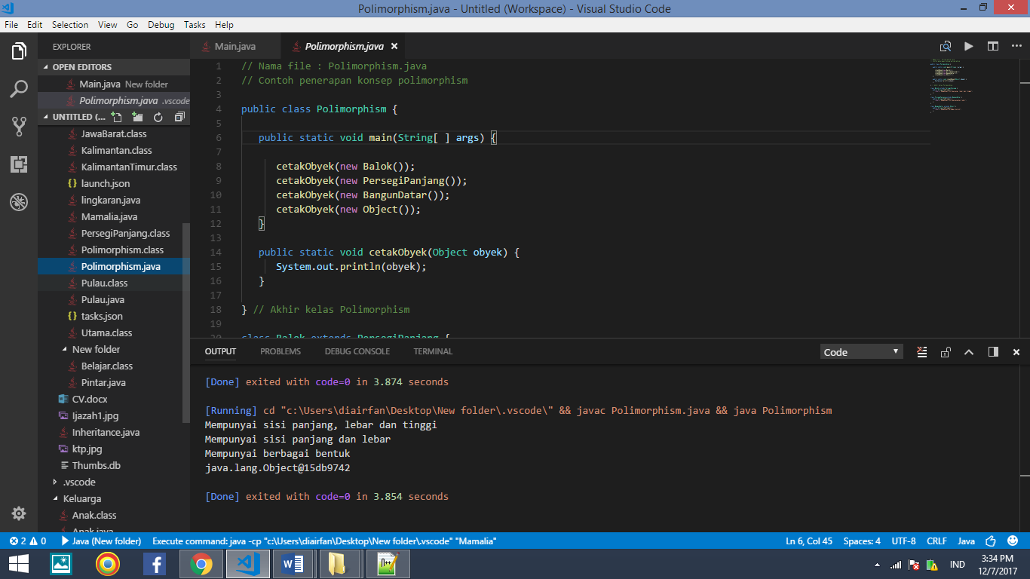

*Enkapsulasi*

public class Pintar{

public static void main(String[]args){

Coba panggil = new Belajar();

System.out.println(“Panggil X : “+panggil.x);

System.out.println(“Panggil Y : “+panggil.y);

}}

class Belajar{

public String x =”Pintar”;

private String y = “Java”;

}

public class Main {

public static void main(String[] args) {

Person ren = new Person();

ren.setAge(19);

ren.setName("Irfan Syaripudin");

ren.setPersonId("13121994");

System.out.println("\nMy Name Is" +ren.getName() +"\nMy Age : "+ ren.getAge()+"\nMy Id :"+ ren.getPersonId());

}

}

public class Person {

private int age;

private String name;

private String PersonId;

public void setAge(int newValue) {

age = newValue;

}

public void setName (String newValue){

name = newValue;

}

public void setPersonId(String newValue){

PersonId = newValue;

}

public int getAge(){

return age;

}

public String getName(){

return name;

}

public String getPersonId(){

return PersonId;

}

}

Out put

